On a Windows Box

1. Install Anaconda. On a UEA machine, go to the software centre and install from there
2. Install git (as above). Didn’t load from the software centre for me, so

<https://git-scm.com/>

1. Install visual studio. Its monstrous. There is a version on the software centre

<https://visualstudio.microsoft.com/visual-cpp-build-tools/>

you do not need the whole of visual studio, just the C++ build tools

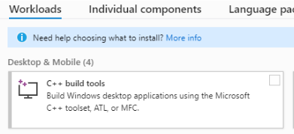

1. Install github desktop from the software centre
2. Download the repository:

 git clone https://github.com/alan-turing-institute/sktime.git

1. Create an environment

conda create -n sktime_env python=3.7 numpy cython  
conda activate sktime_env  
cd sktime  
pip install -e . (DON’T FORGET THE DOT)

1. Open the project in pycharm
2. Settings -> project -> python interpreter. Click cog to change it

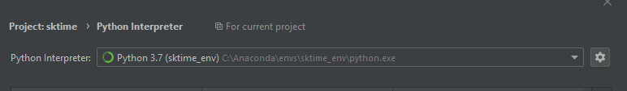

1. Run experiments.py (after adjusting paths in main) through run menu (otherwise it runs tests only)
2. Add existing repository in github desktop

Old notes from experiments.py

*Note ProximityForest and ElasticEnsemble use cython implementations of the distance measures.   
You need a c++ compiler for this.  
These are notes mainly for me.  
On windows:  
The easiest way to install visual studio. Then, from an anaconda prompt, change to the sktime dir, then  
python setup.py install  
python setup.py build_ext -i  
(may not be necessary with pipinstall).  
  
on the cluster  
copy source over then as above,  
enter interactive mode, got to sktime root  
IF not done before,  
  
1) >interactive  
2) change dir to sktime  
3) module add python/anaconda/2019.3/3.7  
4) conda init bash  
5) conda create -n sktime  
6) conda activate sktime  
7) conda install pip  
8) pip install setuptools scipy cython numpy pandas scikit-learn pytest statsmodels  
9) export PYTHONPATH=$(pwd)  
10) python <FULLPATH>setup.py install  
11) python <FULLPATH>setup.py build_ext -i  
  
then run sktime.sh script*